GRAPHING CLUES
These are portions of rides rather than the whole ride.
_____________________________________

Ride Profile – Altitude versus Time

Can you identify specific features from this graph?

Lift Hill – where a coaster goes up to gain potential energy. If there’s a definite lift hill, then it’s probably a roller coaster. If not, it’s probably not a roller coaster

First Dip – bottom of the first hill. This is usually the place where the biggest forces happen on coasters.

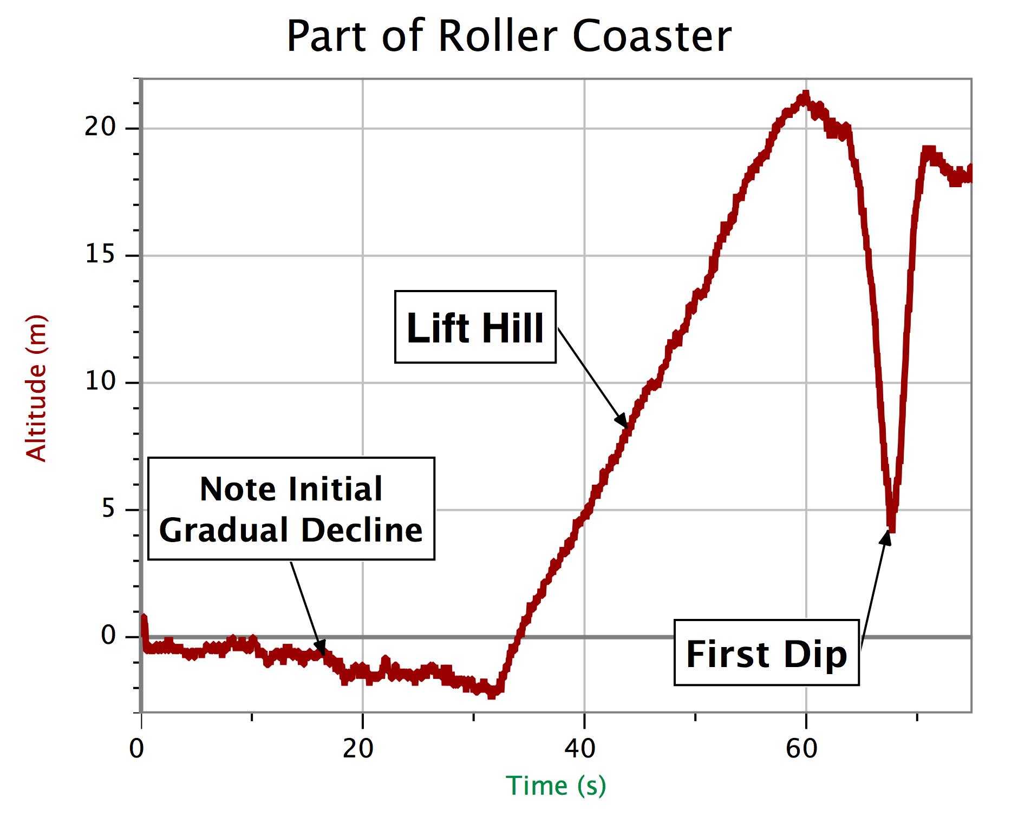
This graph comes from a ride with a vertical loop. The loop often occurs near the bottom of the first hill.

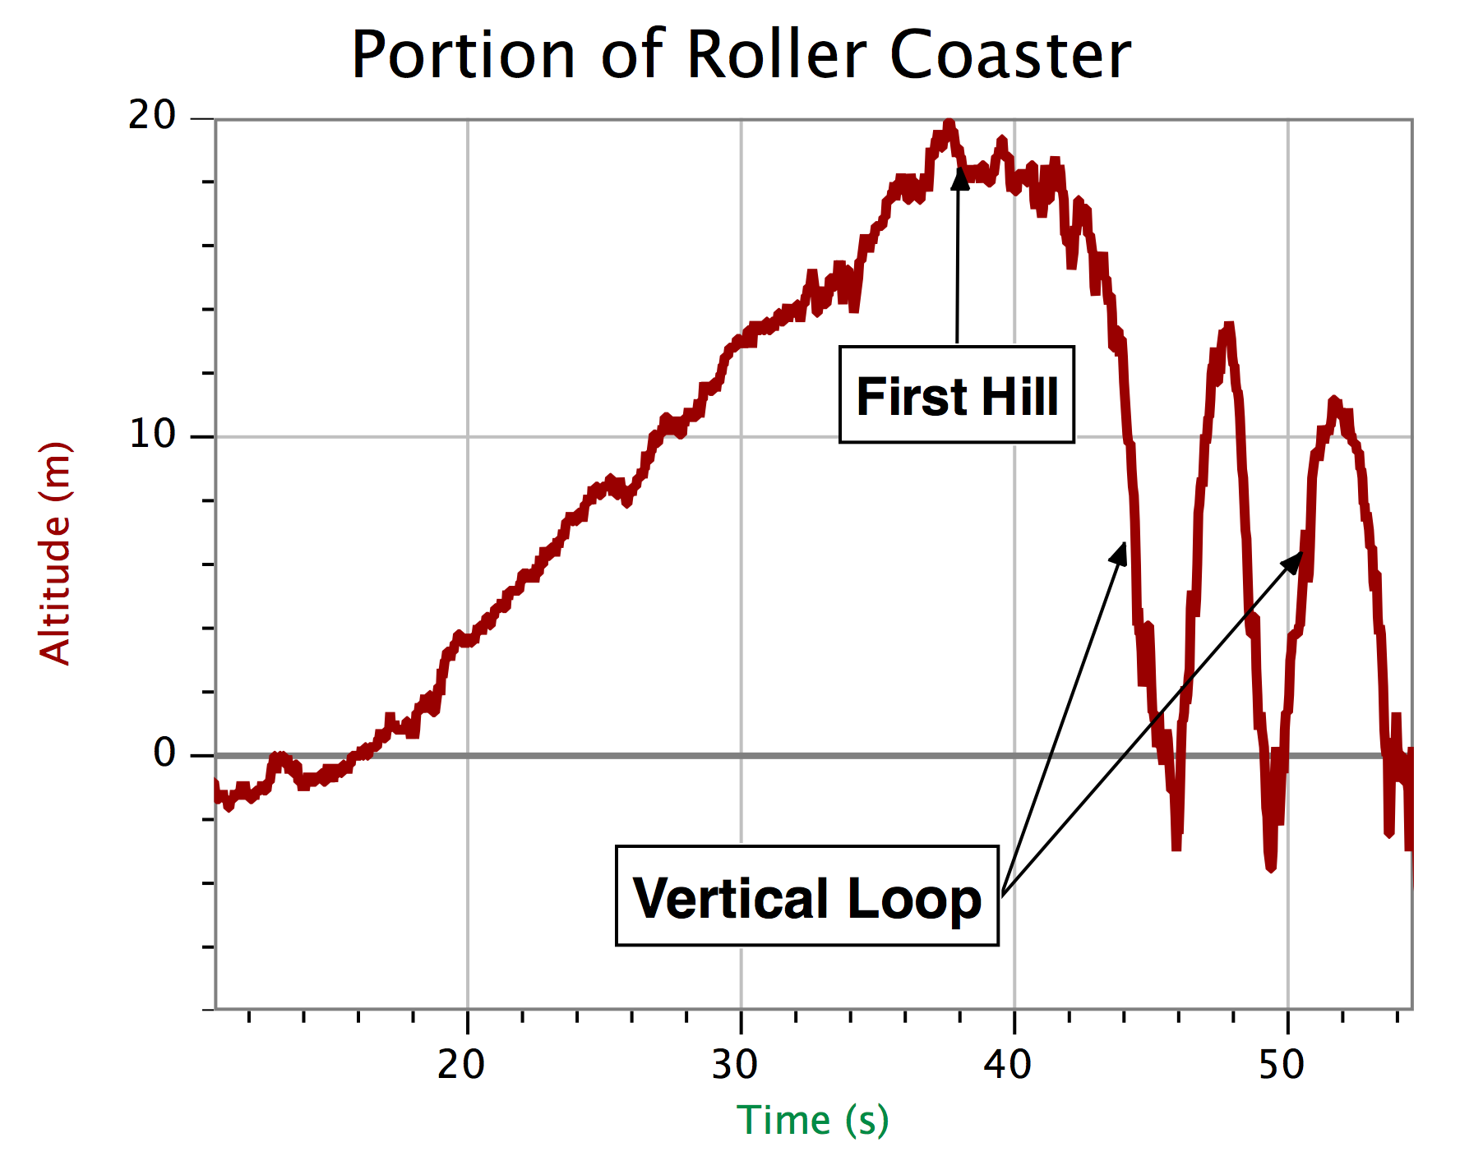

Note how time can’t go backwards, so a loop shows up as “W”.

Can you see the lift hill portion clearly here?

Note: Not all the lines on your graphs will be perfectly smooth due to slight bouncing of the cars and other factors.

Vertical Forces – Up and Down along spine

Big vertical forces occur when riders go through dips on Roller Coasters as shown in the graph below.
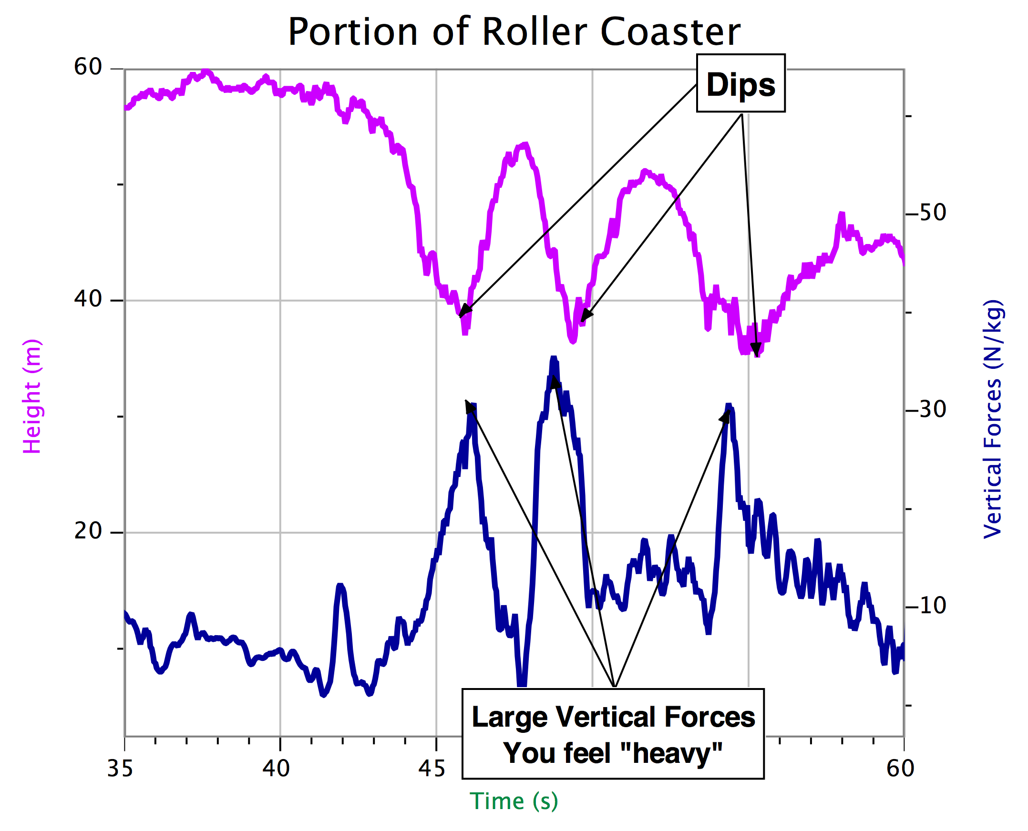

Lateral Forces – Side to Side

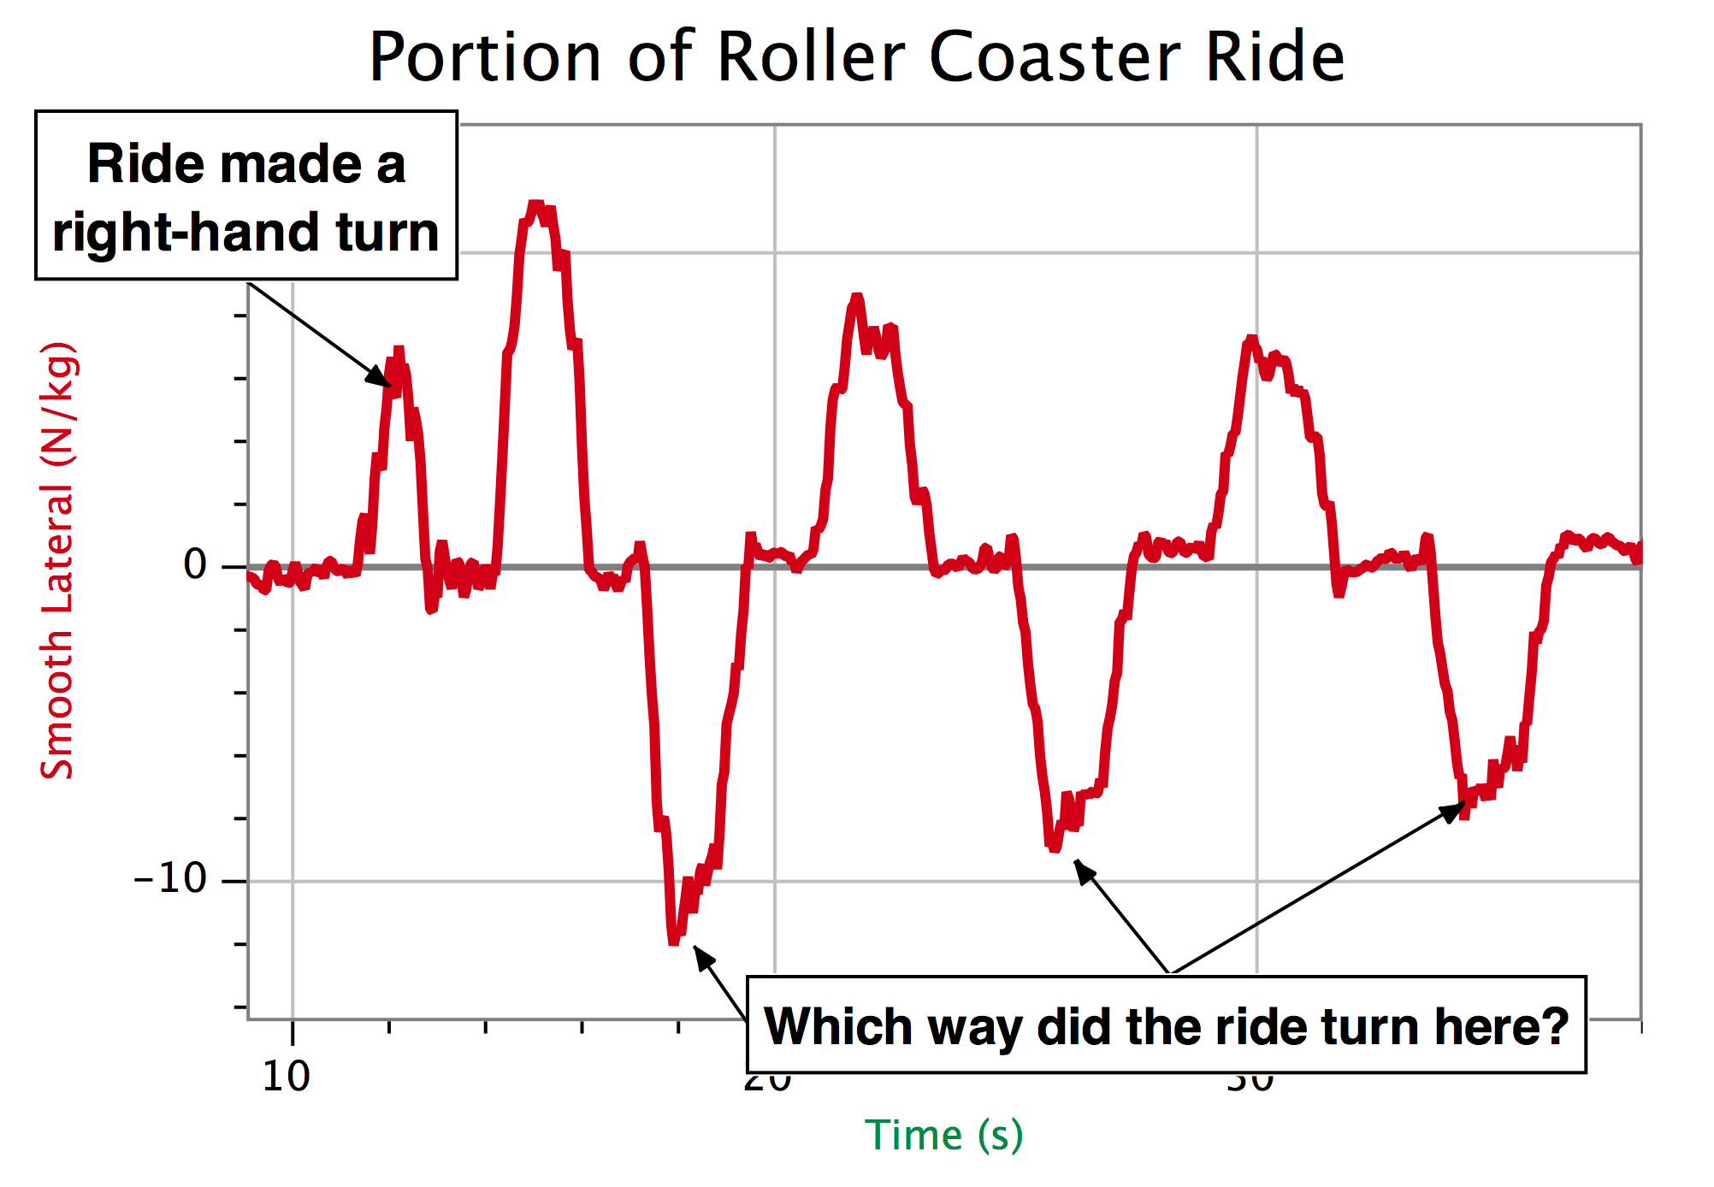

This ride has a series of zig-zags. Can you identify the directions of the various turns given the clue you were given?
Longitudinal Forces – To Front or To Back

This ride repeats itself with regularity. Would it be a roller coaster or perhaps a circular ride? Explain.

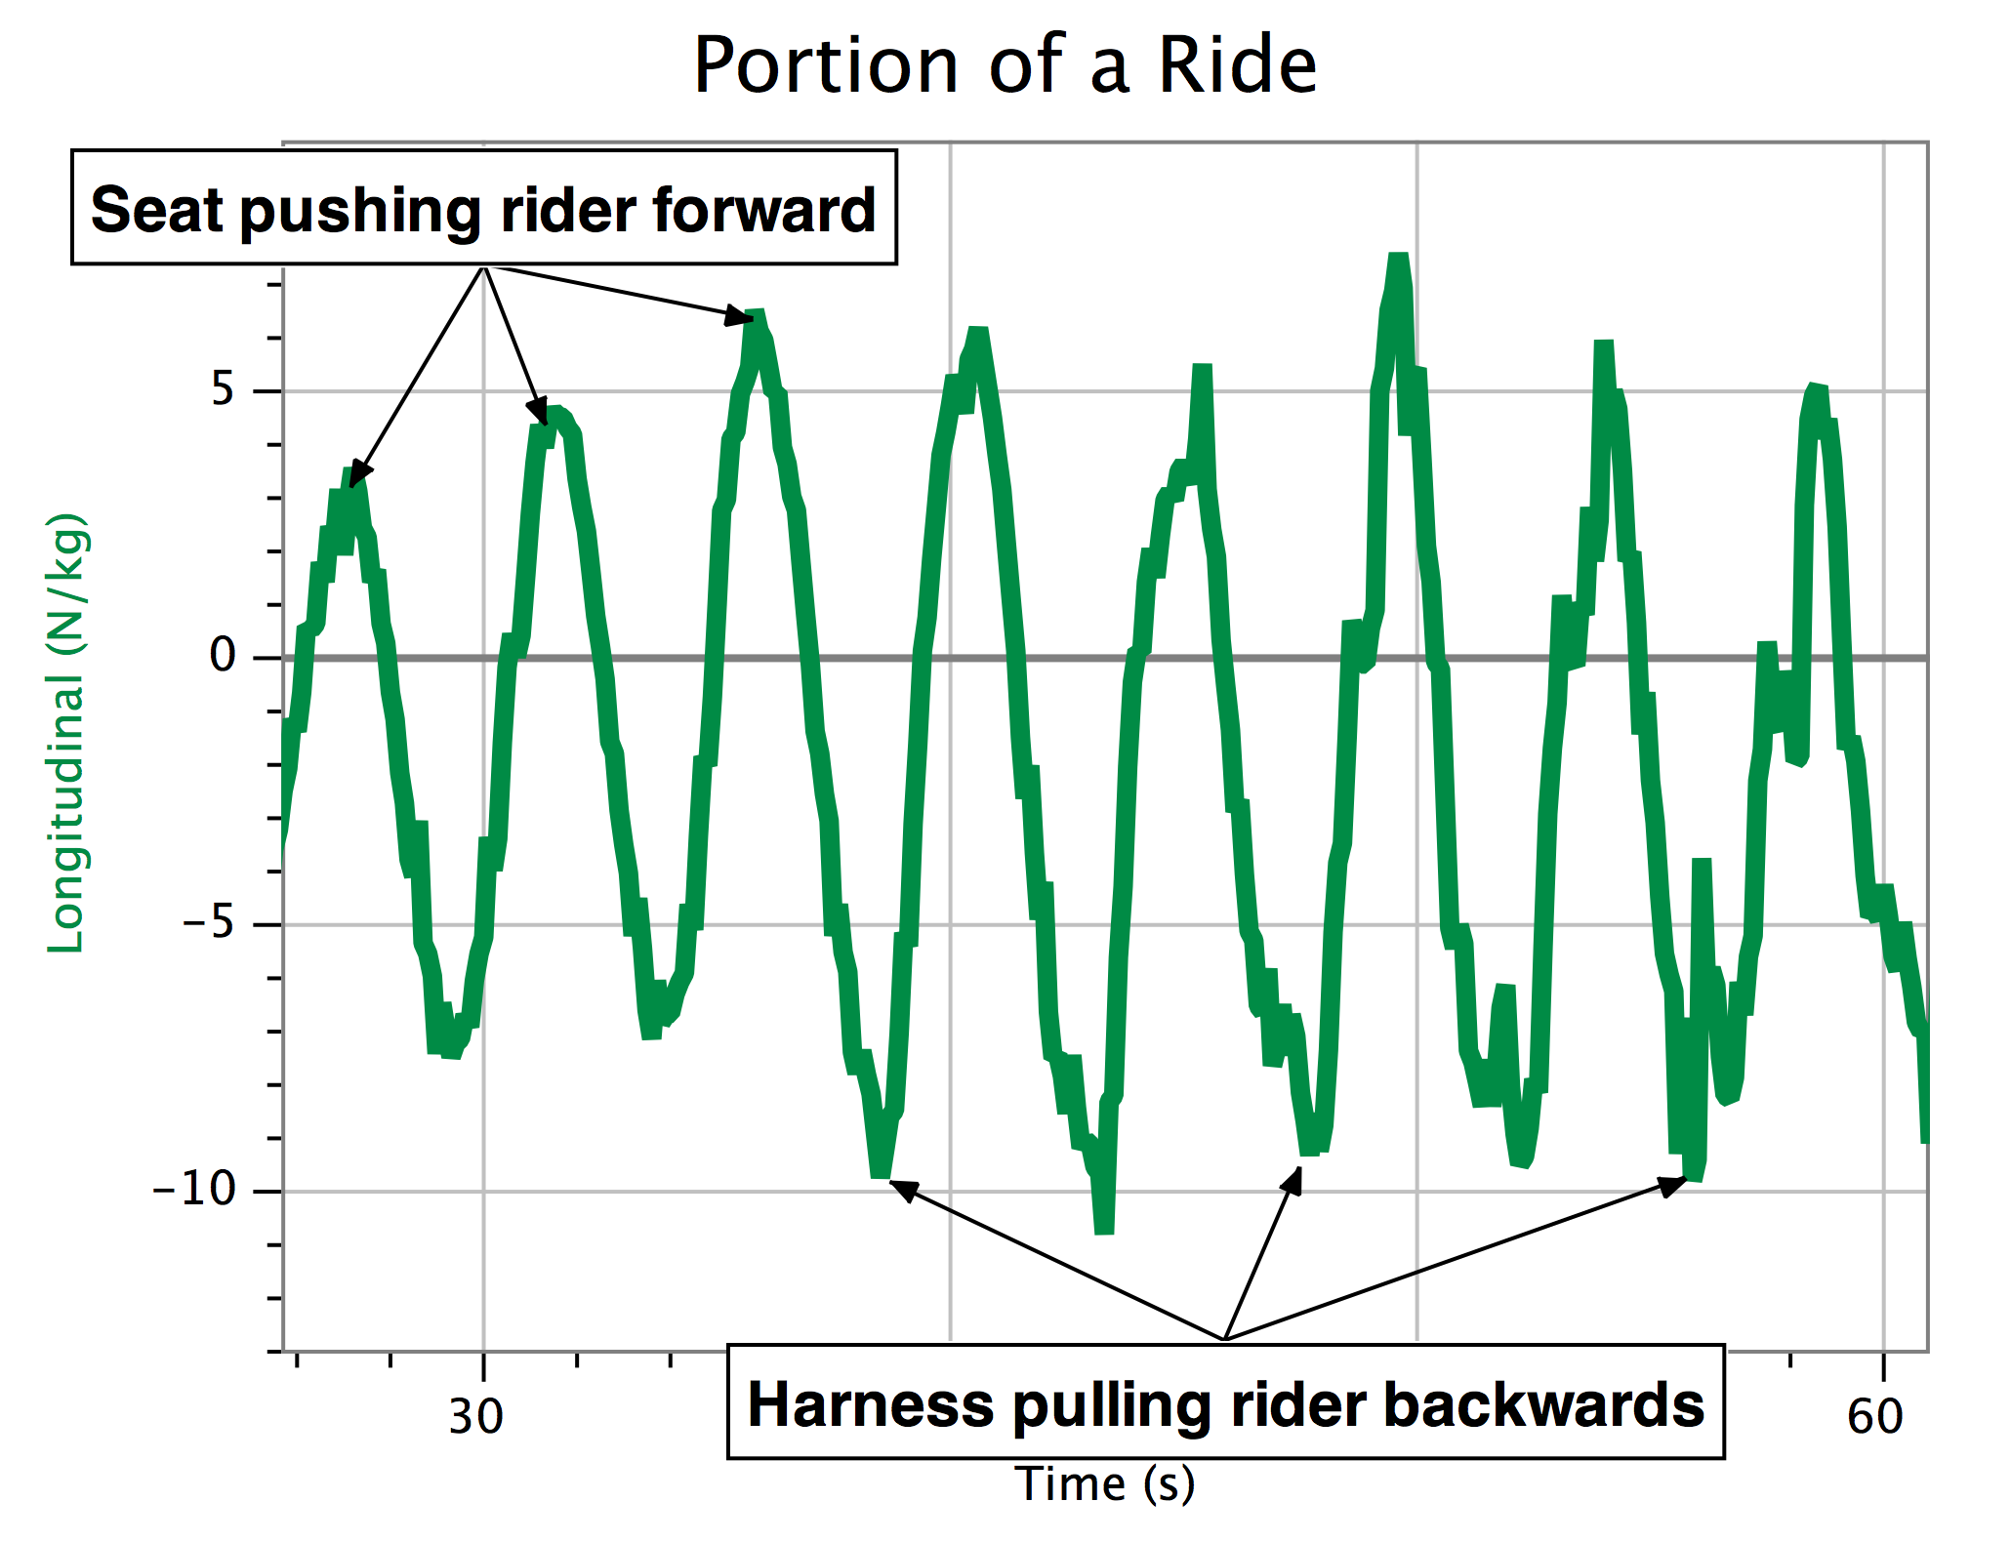

GENERAL APPROACH:

Read the vertical axis label. What quantity is being plotted?

Do you have information that tells you it is a roller coaster? If so, this limits the options.

If it is a roller coaster, is there a vertical loop section? Is there more than one? Do they come close together or far apart?

If it isn’t a roller coaster, what clues do you have about the ride? Do the forces come at regular intervals? Check the x-axis label to see how much time is involved.

Limit things down to two choices, then do your best.

Teacher Steering Committee
2017

