Roller Coasters with Loops

In the Classroom

- Fill a small clear-plastic water bottle one-quarter full with colored water and cap the bottle tightly. Have your teacher or another adult tie a string around the neck of the bottle.

- Hold the bottle right side up, then on it side, then upside down, and then on its other side as shown in drawing A.

- On drawing A, color the bottles to show how the water looked in each position.
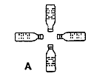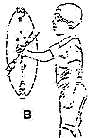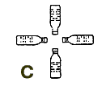
- Now carefully swing the bottle in a circle as shown in drawing B. Notice how the water looks in the bottle as it is swung in a circle. On drawing C, color the bottles to show how the water looked in each position.

- Swing the bottle in a circle more slowly. What effect does slowing the speed of the bottle have on the water and on the bottle?

Prediction

Imagine that you are at the top of the loop on the coaster. Circle the sentence below that best describes what you think will happen.

- The lap bar will keep me from falling out.
- I will be pushed into the seat
- I will be pushed forward by the seat's back.

