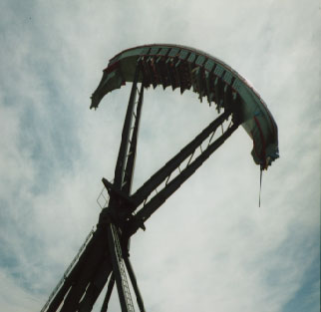
Ride Name: HMB Endeavor
Ride Type: 360º Looping Ship or Boat

Goal: To identify places of greatest kinetic and potential energy and to observe that energy is conserved

Related Terms: kinetic energy, potential energy

Concept
A pendulum illustrates the conservation of energy. The pendulum has the most potential energy – the energy of position or stored energy – when it is highest above the ground. It has the most kinetic energy – the energy of motion – when it is moving the fastest. As the pendulum swings downward, the potential energy changes to kinetic energy. As it swings upward, the kinetic energy changes to potential energy. The back-and-forth swinging of a pendulum is simple harmonic motion – motion that repeats periodically. The period of a pendulum is the time needed for one complete swing back and forth. This period is constant; it changes only if the length of the pendulum is changed.

Classroom Activity
Ask students to describe how it feels to swing on a playground swing. Explain that an object that swings back and fort as a playground swing does is called a pendulum. Tell students that at parks such as California’s Great America there are rides with motions that are similar to those of a pendulum. Distribute to each student or group the activity sheets and tape, string, and a heavy steel washer. The activity uses the pendulum motion to introduce the concepts of potential energy and kinetic energy. After discussing these concepts, have a student draw on the chalkboard a pendulum in the position in which it would have the most potential and the most kinetic energy.

Pre-Visit Prediction
Have students look at the drawing of the ride. Explain that the ride swings back and forth like a pendulum, but it will eventually make a complete loop. Ask students to predict the position in which the ride will have the most kinetic energy.

After the Experience
Ask student to time the periods of their pendulums when the pendulums swing through a longer distance (larger arc) or shorter distance (smaller arc). They will discover that the periods are the same. Have the students then change the mass by adding one or more washer to their pendulum. When the students time the periods, they discover that the period does not change if the mass is changed. Ask students to experiment to find what will change the period of the pendulum. Students will discover that the period will change if the pendulum’s length is changed.
Ride Name: HMB Endeavor
Type of Ride: 360º looping ship or boat

Classroom Activity

Think about riding on a playground swing. Think about how you “pump” to make the swing go higher.

Now tie one end of a string to a heavy washer. Tie the other end to a pencil and hang the washer from the pencil as shown on the left. Pull the washer to the side and release it. Observe how the washer changes speed. Both the playground swing and the washer on a string are pendulums. At what place in the swing of a pendulum does it move the fastest?

A pendulum must receive energy to swing. How does the pendulum you made get its energy?

As a pendulum swings, its energy changes. When the pendulum is high above the ground, it has potential energy – the energy of position. When the pendulum is moving, it has kinetic energy – energy of motion. When does the pendulum have the most potential energy?

When does it have the least potential energy?

When does the pendulum have the most kinetic energy?

When does it have the least kinetic energy?

As the pendulum falls, what does the potential energy change into?

As the pendulum rises, what does the kinetic energy change into?

Prediction
On this drawing, put an X at the place where the ride has the most kinetic energy.

Observe HMB Endeavor in the park.

When is Endeavor moving the fastest?

When is it moving the slowest?

Ride Endeavor. Put a hand under one thigh. When do you feel the greatest force on your hand?

When do you feel little or no force on your hand?

POTENTIAL KINETIC
ENERGY ENERGY

