

SPOTS

The Teacher Steering Committee determined that one of the biggest sources of error for students taking height measurements is the baseline distance. It is very difficult to get an accurate measurement, or sometimes even a good estimate, of this important quantity.

To improve the quality of students' work, the park has placed five "SPOTS" and provided a sign with measurements to places we feel would be useful to students doing their work. In addition, we have modified some of the packet activities to take more advantage of the SPOTS.

The SPOTS and the measurements students should be able to get there:

REVOLUTION

This SPOT is at the northwest end of the covered bridge leading to Kidzville under the Kodak Picture Spot. Students will know the horizontal distance from here to the center of the boat when it is in its resting position.

FLIGHT DECK

The Flight Deck SPOT is just to the right of Great America Outfitters, just to the left of Showtime Theater. From here, they will know their horizontal distance to a point directly below the top of the lift hill, to the bottom of the track leading into the vertical loop, to a point below the top of the vertical loop, and to the bottom of the track exiting the loop.

DROP TOWER

The Drop Tower SPOT is next to a lamp post directly in front of the loading platform for Psycho Mouse. Students will know their horizontal distance to the bottom of the Drop Tower tower.

XTREME SKYFLYER

The Xtreme Skyflyer spot is on the bridge that's an exit for Whitewater Falls. Go past the point where you would get wettest, and the spot is next to the "Splash Zone" sign. Students will know the horizontal distance to the nearest loading platform for Skyflyer, and also the horizontal distance to a point directly below the riders when they are at their highest position.

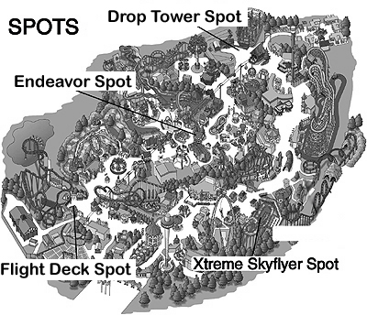

January 2012

