Electronic Data on Roller Coasters

Before you ride
- The name of the ride you went on is: _______________________________________
- Make a sketch of the ride profile on the back of this page. Mark the approximate position of a passenger every 10 seconds on your sketch. (This can be worked out either before or after riding.)
- In the space below, describe your data collection strategy for this ride. Will you collect data for the entire ride, or concentrate on a specific portion? Which portion? How long does it take to go through the ride or that part of the ride, and how many data points would you like to acquire? Which axis or axes of acceleration will you focus on in your analysis?

While you ride
Secure the measuring unit in a fixed orientation relative to your body. The three axes are straight ahead (longitudinal), directly to the side (lateral) and/or straight up and down (vertical). If an axis is not used, don't circle it.
- Accelerometer X: longitudinal - lateral - vertical (circle one)
- Accelerometer Y: longitudinal - lateral - vertical (circle one)
- Accelerometer Z: longitudinal - lateral - vertical (circle one)

When you reach the place on the ride where you want to begin collecting data, press [Start/Stop].

After you ride
Return the data collection unit back to the Electronic Data Center (EDC). Download the data. If possible, they will print the graphs of your forces vs. time so you can do onsite analysis. The data will also be posted online so you can download it and work further with it later.

Questions:
Use the back of this page to answer the questions below. Use the ride profile to determine where you were on the ride for each of these portions. Also note any peculiar accelerations encountered.
- Describe the graph(s) during the initial seconds you recorded. Compare the shape of the graph(s) to your movement during that portion of the ride.
- For each of your axes, where were the readings the greatest? What were the readings there? Explain why the readings were the greatest at those points.
- For each of your axes, where were the readings the least? What were the readings there? Explain why the readings were the least at those points.
- The larger the forces that act, the larger the acceleration acting on your body. Do the places where the unit recorded the largest values for force/mass the same places you experienced the largest accelerations? Explain.

Ride Profile:
- In this area, sketch the shape of the ride if it were stretched out linearly. Sketch loops as loops. Make other notations that will help you to decode your data later on.
- Indicate on your ride profile the approximate location of a passenger every 10 seconds. This will enable you to match up your accelerometer data with your location on the ride.

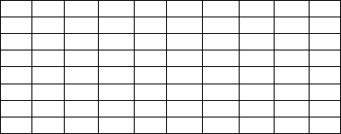

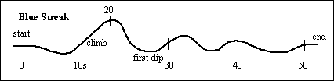
Example: A simple roller coaster for toddlers that makes a single loop around a closed track.

January 2012

