GoldStriker Worksheet

Use the diagram below and your experience on the ride to answer the questions that follow.
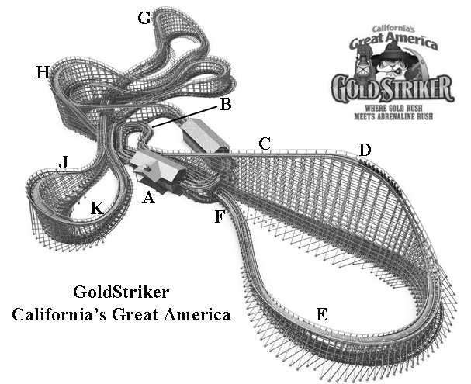
Several descriptions follow. Use the letters in the diagram to match up each description with the place on GoldStriker where it applies. A letter may be used more than once or not at all. If there are multiple blanks in front of a description, more than one place will apply.

_____ 1. At the lowest point in the ride
_____ 2. At the highest point in the ride
_____ 3. Going at a constant speed
_____ 4. Going at the fastest speed
_____ ______ 5. Gaining gravitational energy
_____ ______ 6. Losing gravitational energy
_____ 7. Lift hill
_____ _____ 8. Gaining kinetic energy
_____ ______ 9. Losing kinetic energy

10. Compare places G and H. Of these two, where will the riders feel the greatest force? Why? What factors affect the forces they feel at these two places?

Essay: On the back of this sheet, describe an experiment that you might carry out on GoldStriker. What question(s) will you investigate? What instruments will you use? How will you know if you have done a good job with your investigation?

