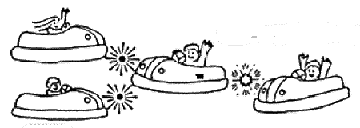
RUE LE DODGE

Qualitative

1. In a head-on crash, you feel like you are thrown a. forward b. backward

2. When you are hit from the rear, you feel like you are thrown a. forward b. backward

3. You feel like you are thrown forward when your car a. stops b. starts

4. You feel like you are thrown backward when your car a. stops b. starts

5. You feel the biggest jolt when you hit another car
a. head on b. in the back c. on the side

6. Taking a look at items 1-4 above, describe what really happens to you in each case. Use Newton's 1st Law of Motion in your thinking.

7. Use MASS and ACCELERATE in two sentences about the BUMPER CARS.

RUE LE DODGE cont.

Each drawing below represents an overhead view of two bumper cars just before they collide. The circle in the middle of each drawing represents the location of the rider. The arrows indicate the direction each car is moving.
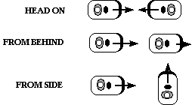

Directions: Draw your own arrow within each circle showing the direction the rider is thrown by the collision.

For each kind of collision, use the concept of MOMENTUM to explain the direction of your arrows showing how passengers are thrown by the collision.
RUE LE DODGE
Quantitative

DATA:

Quantity* | Value | How Measured**

* Mass, Distance, Time, etc.
** How did you get your value?

PROBLEMS:
Based on your measurements, estimates, or other data available to you,

- How fast do the cars in this ride move? Show your work.

- How much time is required to accelerate from rest to full speed?

- What is the acceleration rate for a car in this ride?

QUESTIONS:

- During a typical collision, do the cars tend to stick together, bounce back at speeds equal to the original ones, or bounce at speeds less than their original ones?

- Based on your answer to question (4), how would you characterize the collisions -- elastic, inelastic or partially elastic? Explain.

3. Describe how the cars on this ride get their energy.

