Physics Day at California’s Great America

Stay At Home Packet

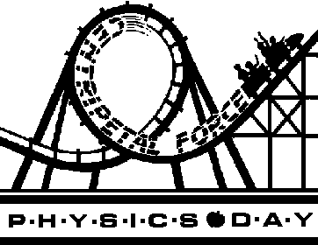

Name Teacher Period

Name Teacher Period

This packet is due, completed, at the beginning of class on Monday. It is worth the same number of points as the packet that students complete while at the park.

