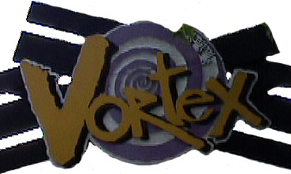
The Vortex

The Vortex is a looping, twisting steel stand-up roller coaster designed to give you a hair-raising ride at speeds of up to 20 m/s (45 mph). Without a proper chair to sit down on, this ride is bound to keep you on the edge of your seat!

Measurements & Observations

- As you wait in line, measure how long it takes for each coach to complete a trip around the track. Do not include the loading/unloading time as part of this measurement. In order to achieve a good accuracy, average together at least five separate timings to find the mean ride time.

________ Average time of ride: Individual data:

- Using distance = rate x time, and the fact that the ride is 585 m long (1960 ft or 0.364 mile) calculate the average speed of a coach as it makes one trip around the track.

________ Average speed of ride

- On the track layout below, use colored highlighters to indicate where the coaches are moving fastest and slowest. Also record your three speed estimates from the following exercise at the appropriate locations.

Measurements & Observations, continue

- Now watch the coaches as they roll around the track from one of the observation areas. Using a watch for time and your best distance estimation skills, calculate the approximate speed of the coach at the three fastest points along the track. Show your work.

- In the space below, discuss at least three reasons why the average speed you calculated at the start of this worksheet does not (and should not) agree with the published top speed or your estimates from the previous exercise.

