Physics/Science/Math Days Crossword Puzzle
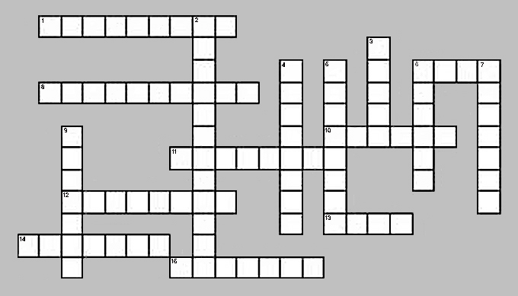

ACROSS

1. An energy form based on position above or below another point
6. Product of force and distance moved; amount of energy changed from one form to another
8. No net force between object and its surroundings; free fall
10. Ability to do work; comes in many forms at the amusement park
11. Resistance to motion due to one object rubbing against another
12. How fast an object is moving combined with its direction
13. Quantity of matter in an object
14. Side-to-side
15. Resistance of an object to moving or changing its motion

DOWN

2. Rate at which the velocity changes; F/m
3. A push or pull; usually leads to an object changing its motion
4. Aligned with the rider’s back; not horizontal
5. Mathematically the tendency of a body to keep moving; product of mass and velocity
6. Effect of gravity’s pull on an object’s mass
7. Adjective meaning “active” or “in motion”; type of energy
9. Force of attraction between two bodies that have mass

Word List for Crossword Puzzle

Acceleration Kinetic Potential
Force Mass Velocity
Friction Momentum Weight
Gravity Energy Weightless
Inertia Work Lateral
Vertical

Answer to Puzzle

