The Demon!
Read before Riding!

Quantitative Observations:

DATA
Length of track = 2,300ft or 700m
Height of first hill = 100ft or 30.3m
Height of 1st loop = 78ft or 23.6m
Height of 2nd loop= 55ft or 16.7m

While Standing in line...

Time of ride = ___________seconds.

Length of train = _____________ft or ____________m
(estimate length of one car X # of cars)

While riding ... ( using accelerometer)

Maximum acceleration = ___g’s at______________.
(location)
Acceleration at top of loop #1 =____g’s
Acceleration at top of loop #2 =____g’s

From Observation Area...

Time for entire train to pass a point at the bottom of first hill = _____seconds.

Time for entire train to pass a point at the top of the 1st loop = _____seconds.

Time for entire train to pass a point at the top of 2nd loop = _____seconds.

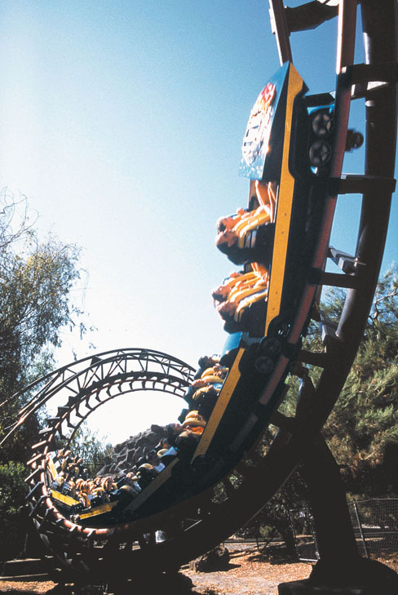

Qualitative Observations:

1. Did you sit in the front, back or middle of the train?
2. Did you feel more force going into or out of the loops? Explain.
3. Compare how the force felt while in loop 1 and the in loop 2.
4. Explain why you think your accelerometer did or did not measure accurately.
5. The coaster travels slowest when it is
a. highest, b. lowest.
6. When you enter the loop you feel
a. heavier, b. lighter than you usually do.
7. When you reach the top of the loop you feel …..
a. heavier, b. lighter than you usually do.
8. You felt heaviest
- when you entered the loop
- b. at the top of the loop
- c. at the end of the loop
9. While you circle through the loop, you seat seems to be forcing you
a. away from, b. toward the center of the loop.
10.While you go through the corkscrew, which way does your seat seem to be forcing you?
11.Explain why the loops have different heights?

THE DEMON

- The coaster travels slowest when it is ….. a. highest b. lowest.
- When you enter the loop you feel ….. a. heavier b. lighter ….. than you usually do.
- When you reach the top of the loop you feel ….. a. heavier b. lighter ….. than you would usually.
- The coaster gains speed as it …... a. climbs b. falls.
- While circling around inside the loop, the coaster pushes your body
a. away from b. toward ….. the loop’s center.
- At what point on the loop do you feel the lightest?
- At what point on the loop do you feel heaviest?
- When are you gaining speed?
- Do you ever feel like you are going to fall out?
Why?
- What direction is your body pushed as you go around in the loop?

- Use GRAVITY and KINETIC ENERGY in two sentences about the loop.

