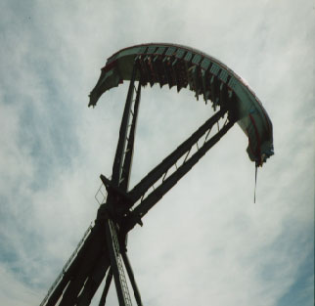
HMB ENDEAVOR

- To feel the lightest, you should sit
a. closer to b. farther from
the center of the gondola.
- When you are highest above the ground, you are
traveling ….. a. slowest b. fastest.
- When the gondola changes directions, you feel
a. lightest b. heaviest.
- You feel ….. a. the same b. different ….. swinging forward as you do swinging backward.
- When you are the highest above the ground, you feel the
a. lightest b. heaviest.

- Use GRAVITY and WEIGHTLESS in two sentences about ENDEAVOR.

