Make a Graph
One of the most effective methods of describing motion is to plot graphs of position, velocity, and acceleration vs. time. From such a graphical representation, it is possible to determine in what direction an object is going, how fast it is moving, how far it traveled, and whether it is speeding up or slowing down. In this experiment, you will use a Motion Detector to plot real time graphs of your motion as you move across the classroom.
The Motion Detector measures the time it takes for a high frequency sound pulse to travel from the detector to an object and back. Using this round-trip time and the speed of sound, the interface can determine the distance to the object; that is, its position. It can then use the change in position to calculate the object’s velocity and acceleration. All of this information can be displayed in a graph. A qualitative analysis of the graphs of your motion will help you understand the concepts of kinematics.
objectives
- Understand the relationship between shape of kinematics graphs and the motion that produced them
Materials
LabQuest | meter stick
LabQuest App | masking tape
Motion Detector
Procedure
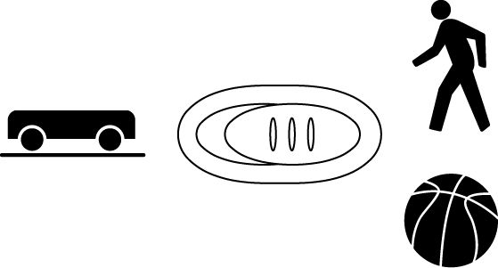
1. Find an open area at least 4 m long in front of a wall. Use short strips of masking tape on the floor to mark distances of 1 m, 2 m, and 3 m from the wall. You will be measuring distances from the Motion Detector in your hands to the wall.
2. If your Motion Detector has a switch, set it to Normal. Connect the Motion Detector to DIG 1 of LabQuest and choose New from the File menu. If you have an older sensor that does not auto-ID, manually set up the sensor.
3. On the Meter (Setup) screen, tap the rectangle containing Mode, Length and Rate information, then change the data-collection length to 10 seconds. Tap on OK to set this new collection time.
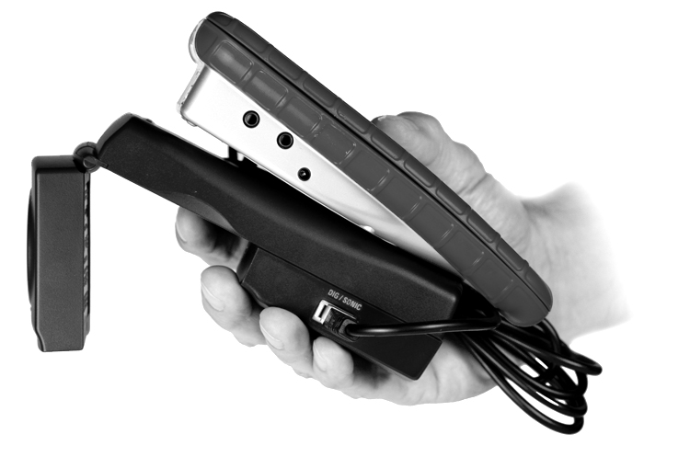
Part l Preliminary Experiments
4. Open the hinge on the Motion Detector. When you collect data, hold the Motion Detector so the round, metal detector is pointed directly at the wall. Sometimes you will have to walk backwards.
5. Monitor the position readings on the Setup screen as you move back and forth. Confirm that the values make sense.
6. Make a graph of your motion when you walk away from the wall with constant speed. To do this, stand about 1 m from the wall and start data collection. Walk backward, slowly away from the wall after data collection begins.
7. You will likely see both a Position and a Velocity graph on the screen. Choose Graph > Show Graph > Graph 1 to view only the position vs. time graph at this time.
8. How will you know you have obtained a good graph? When you get a good graph, describe the shape of that graph.
9. Once you get a good graph, tap the file cabinet icon on the right-hand side to store that run. You are now ready to collect a second run.
10. What will the distance vs. time graph look like if you were to walk backwards at a faster speed? Check your prediction by repeating step 6 but walking backward a bit faster.
11. You should only see one graph line on the screen, the one from your second run. To see both the first and second runs, tap on the button that says “Run 2” and choose “All Runs”. This displays both of your runs on one graph. How can you tell the difference between the first and second run? What differences were there between the two graph lines?
Part Il Making Position vs. Time Graphs
12. Go to the Data Table screen and choose Table > Clear All Data. In the spaces below, you will see a series of graphs on the left-hand side. Use your Motion Detector to move until you have created a graph that matches the one shown. On the right-hand side, describe how you moved in order to create that graph.
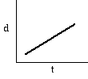
A

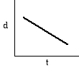
B

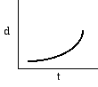
C

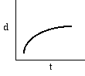
D

13. Go to the Analysis section, Part II to apply your new knowledge.
Part IIl Making Velocity vs. Time Graphs
14. Clear the data by going to the Data Table screen, then tapping Data > Clear All Data. Move back to the Graph screen, then tap on the label for the vertical axis, Position. In the menu that appears, tap on Velocity to change the graph to a velocity vs. time graph.
15. Repeat step 6, observing the velocity vs. time graph you obtain. Describe the shape of the graph and how it tells you about your motion.
16. Store that run (by tapping the file cabinet icon) then repeat step 6 but moving at a faster speed. Tap the Run 2 button and choose All Runs. Compare the two graph lines and compare them to your motions while creating each.
17. Tap the All Runs button and choose Run 2. Note that when you begin collecting a new run, the old one will be deleted or you may be asked if you wish to delete it. This time repeat step 6 but move towards the wall rather than away from it. How does this change the shape of your graph line? When you choose All Runs, how does it change the comparison between your two runs? Compare the results with the motions you made to create the graphs.
18. Go to the Data Table screen and choose Table > Clear All Data. In the space below, you will see graphs on the left-hand side. Use your Motion Detector to move until you have created a graph that matches the one shown. On the right-hand side, describe how you moved in order to create that graph.
E

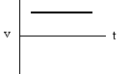
F

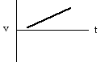
G

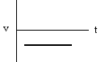

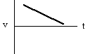
H

19. Go to the Analysis section, Part III to apply your new knowledge.
20. Remove the masking tape strips from the floor and return the LabQuest and Motion Detector to the place your teacher requests of you.
Analysis
Part II Position vs. Time Graphs
- Two Position vs. Time graphs are shown below. For each, describe the motion of the student who created the graph.
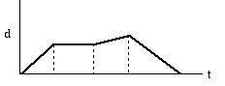
I

II

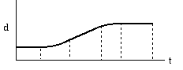

- Return to the procedure and complete Part III.

Part III Velocity vs. Time Graphs
- Two Velocity vs. Time graphs are shown below. For each, describe the motion of the student who created the graph.
III

v
t
IV

v
t

C.Bakken
September 2009

