Periodicity in LabQuest 2

In Physical Science, students often study the characteristics behind the Periodic Table. LabQuest has a routine built into it that will aid in discovering and characterizing what we call “periodicity”.

New File
Start LabQuest app by turning LabQuest 2 on. If your LabQuest 2 is already on, we recommend you create a new file by tapping on File > New. Either save or discard any data that is already in the LabQuest 2 memory.

Periodic Table
Tap on the “Home” icon in the lower task bar, . Select Periodic Table from the menu that appears. Then tap on any of the elements in the table. Note the information that is available for each of the elements. You can put the information away for the current element by tapping the “X” in the upper right-hand corner, then select another element if you wish. To put the whole Periodic Table away, tap the “X” in the upper right-hand corner above the table.
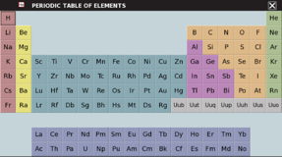

Plotting Table Data
Tap File > Open > periodic_table_data.qmbl then “Open”. Tap on the Graph icon  and you will be presented with a graph of Atomic Radius (pm) versus Atomic Number. “pm” stands for picometer, 10⁻¹² m. Tapping on the graph results in the display of the specific Atomic Radius and corresponding Atomic Number and symbol for the position you tapped. The screen is shown below. If you want to advance ahead by a single atomic number, press the right-hand arrow button 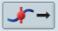. If you want to go backwards a single atomic number, press the corresponding left-hand arrow button.
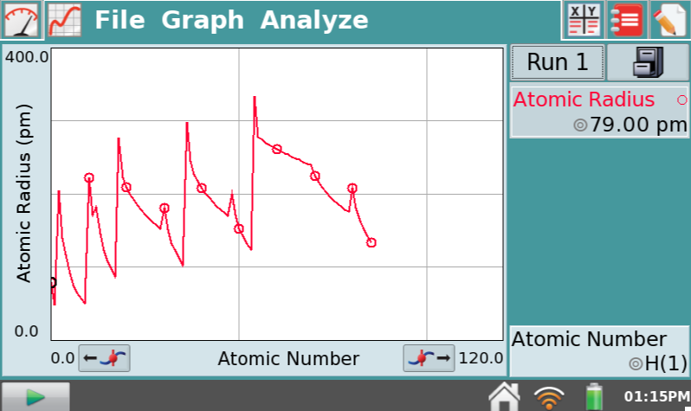

Which elements form the peaks in the Atomic Radius vs. Atomic Number graph? Where are those elements in the Periodic Table? What does this graph indicate about the sizes of atoms in the Periodic Table?

Other Plots
LabQuest 2 can display other quantities for study. Tap on the y-axis label (Atomic Radius (pm)) and choose from the various quantities that are shown to you – Melting Point, Boiling Point, Density, etc. In this way you can study other important qualities of the elements as you move through the Periodic Table.

Even more
Change the y-axis to First Ionization Energy, the energy needed to add or remove an electron from the atom. Tap on the x-axis label and change it to Atomic Radius, the size of the atom. The graph will look very busy with lines connecting all the points, but we can remove them by tapping on Graph > Graph Options. On the lower left-hand side, uncheck the box for “Connect Points” and also the box for “Point Symbols”. When you tap on “OK”, you will see a scatter plot of the data for Ionization Energy vs. Atomic Radius. What does this graph tell you?

Using a similar approach, you can study how the various quantities are related to one another across the Periodic Table.

The use of this powerful tool, which is built into LabQuest 2, is in the hands of the instructors.

Also see: http://www.vernier.com/innovate/periodic-table-graphing/

C. Bakken
August 2015

