Solar Illumination Study

INTRODUCTION

The angle of the sun in the sky relative to the horizon (vertical angle) changes throughout the day as the sun traverses from east to west. And the angle that the sun makes to the horizon changes throughout the year. These are perceptions based on the rotation of the Earth and the Earth’s tilt on its axis. But what are those patterns? How does the patterns change depending on where you live?

To Horizon
(horizontal)
θ
To Sun

This lab is written to utilize sensors in gathering data. By obtaining solar intensity readings, additional studies can be done beyond angle. Teachers and students can choose to investigate one or more of the questions posed, data can be shared for further study, and several STEM extensions could be pursued. Even the equipment used can take various forms depending on which sensors the school owns. Consider this as a “starter” lab where you can make out of it what you would like.

STEM:
We utilize sunlight to heat water for swimming pools or for homes, and to generate electricity using photoelectric cells. These are active solar energy activities. But houses are also designed around solar, permitting sunlight to enter the home during winter and blocking it during summer. This is called passive. On a practical level, how do the changes in the sun’s angle to the horizon affect your decisions about active or passive solar energy? Is there an angle that gives maximum benefit? How does this depend on where you are located?

While the basic description for this lab utilizes the Vernier Goniometer and a Light Sensor, several alternatives exist that can be used effectively. Slight modifications in the step-by-step procedure need to be made. Note that the TI Light Sensor is too sensitive to be used in this experiment. Perhaps if filters are placed over the front like “sunglasses”, one could be used. A third option would be to use a small photovoltaic cell. Instead of recording light intensity, measure the voltage coming from the photocell. This option leads directly to the STEM alternatives described.
QUESTIONS

- What is the vertical angle (θ_{max}) that gives the maximum intensity reading for sunlight?
- How does that angle (θ_{max}) change over the course of a day?
- At what time was the sun at its maximum angle?
- If you place a tube made from black construction paper around the Light Sensor and extending toward the sun, how does this change your results? Should this become a part of the lab as you proceed?
- How does the maximum intensity of light from the sun change over the course of a day?
- How much do the readings you make change from one group to another if multiple groups are collecting data at the same time? Express the differences in terms of percentage.
- How does the angle relative to North (compass heading) change over the course of a school day?
- How does the maximum intensity angle change over the course of a school year?
- How does the angle relative to North change over the course of a school year?
- Is there a best angle for mounting solar cells (photovoltaic cells) that would give a maximum output? At this angle, how does the output change over the course of a day, over the course of a year? And how would you change this angle depending on one’s location?

EQUIPMENT

(Goniometer option)
Goniometer (GNM-BTA) | Light Sensor (LS-BTA)
2”x4”x12” board | 3/8” dowel, 10” long
Option 1: Laptop Computer with Logger Pro software | Interface: LabQuest Mini, 2 Go! Links, LabPro, LabQuest, or LabQuest 2
Option 2: LabQuest or LabQuest 2

(Rotary Motion Sensor option)
Rotary Motion Sensor (RMV-BTD) | Light Sensor (LS-BTA)
3/8” dowel, 10” long
Option 1: Laptop Computer with Logger Pro software | Interface: LabQuest Mini, LabPro, LabQuest, or LabQuest 2
Option 2: LabQuest or LabQuest 2

(Accelerometer option)
Low-g Accelerometer (LGA-BTA) | Light Sensor (LS-BTA)
1”x4”x18” board
Option 1: Laptop Computer with Logger Pro software | Interface: LabQuest Mini, 2 Go! Links, LabPro, LabQuest, or LabQuest 2
Option 2: LabQuest or LabQuest 2

GENERAL PROCEDURE

- Set your apparatus in a location where you can see the sun clearly without any interference from buildings, trees or other obstacles. Line it up so the sun hits the apparatus directly.
- Plug both sensor leads into your interface.
- Set time based data collection to 20 seconds with a data rate of 10 samples/s.
- Establish a reading of zero degrees (0°) with the light sensor parallel to the ground, zeroing the vertical angle measurement. The use of a small spirit level would be helpful.
- Start data collection and slowly rotate your apparatus through a 90° angle, taking most of the 20 second data collection period to do so. You may wish to both raise then lower the apparatus during a single run.
- Set up a graph of Light Intensity versus Angle. Does the angle that gives the maximum intensity θ_{max} show clearly on your graph. Use the Statistics function to determine what the angle θ_{max} is and record it in your logbook along with the date and time the measurement was taken.
- Save the data in a file for future analysis.
- Return equipment to the location your instructor designates.
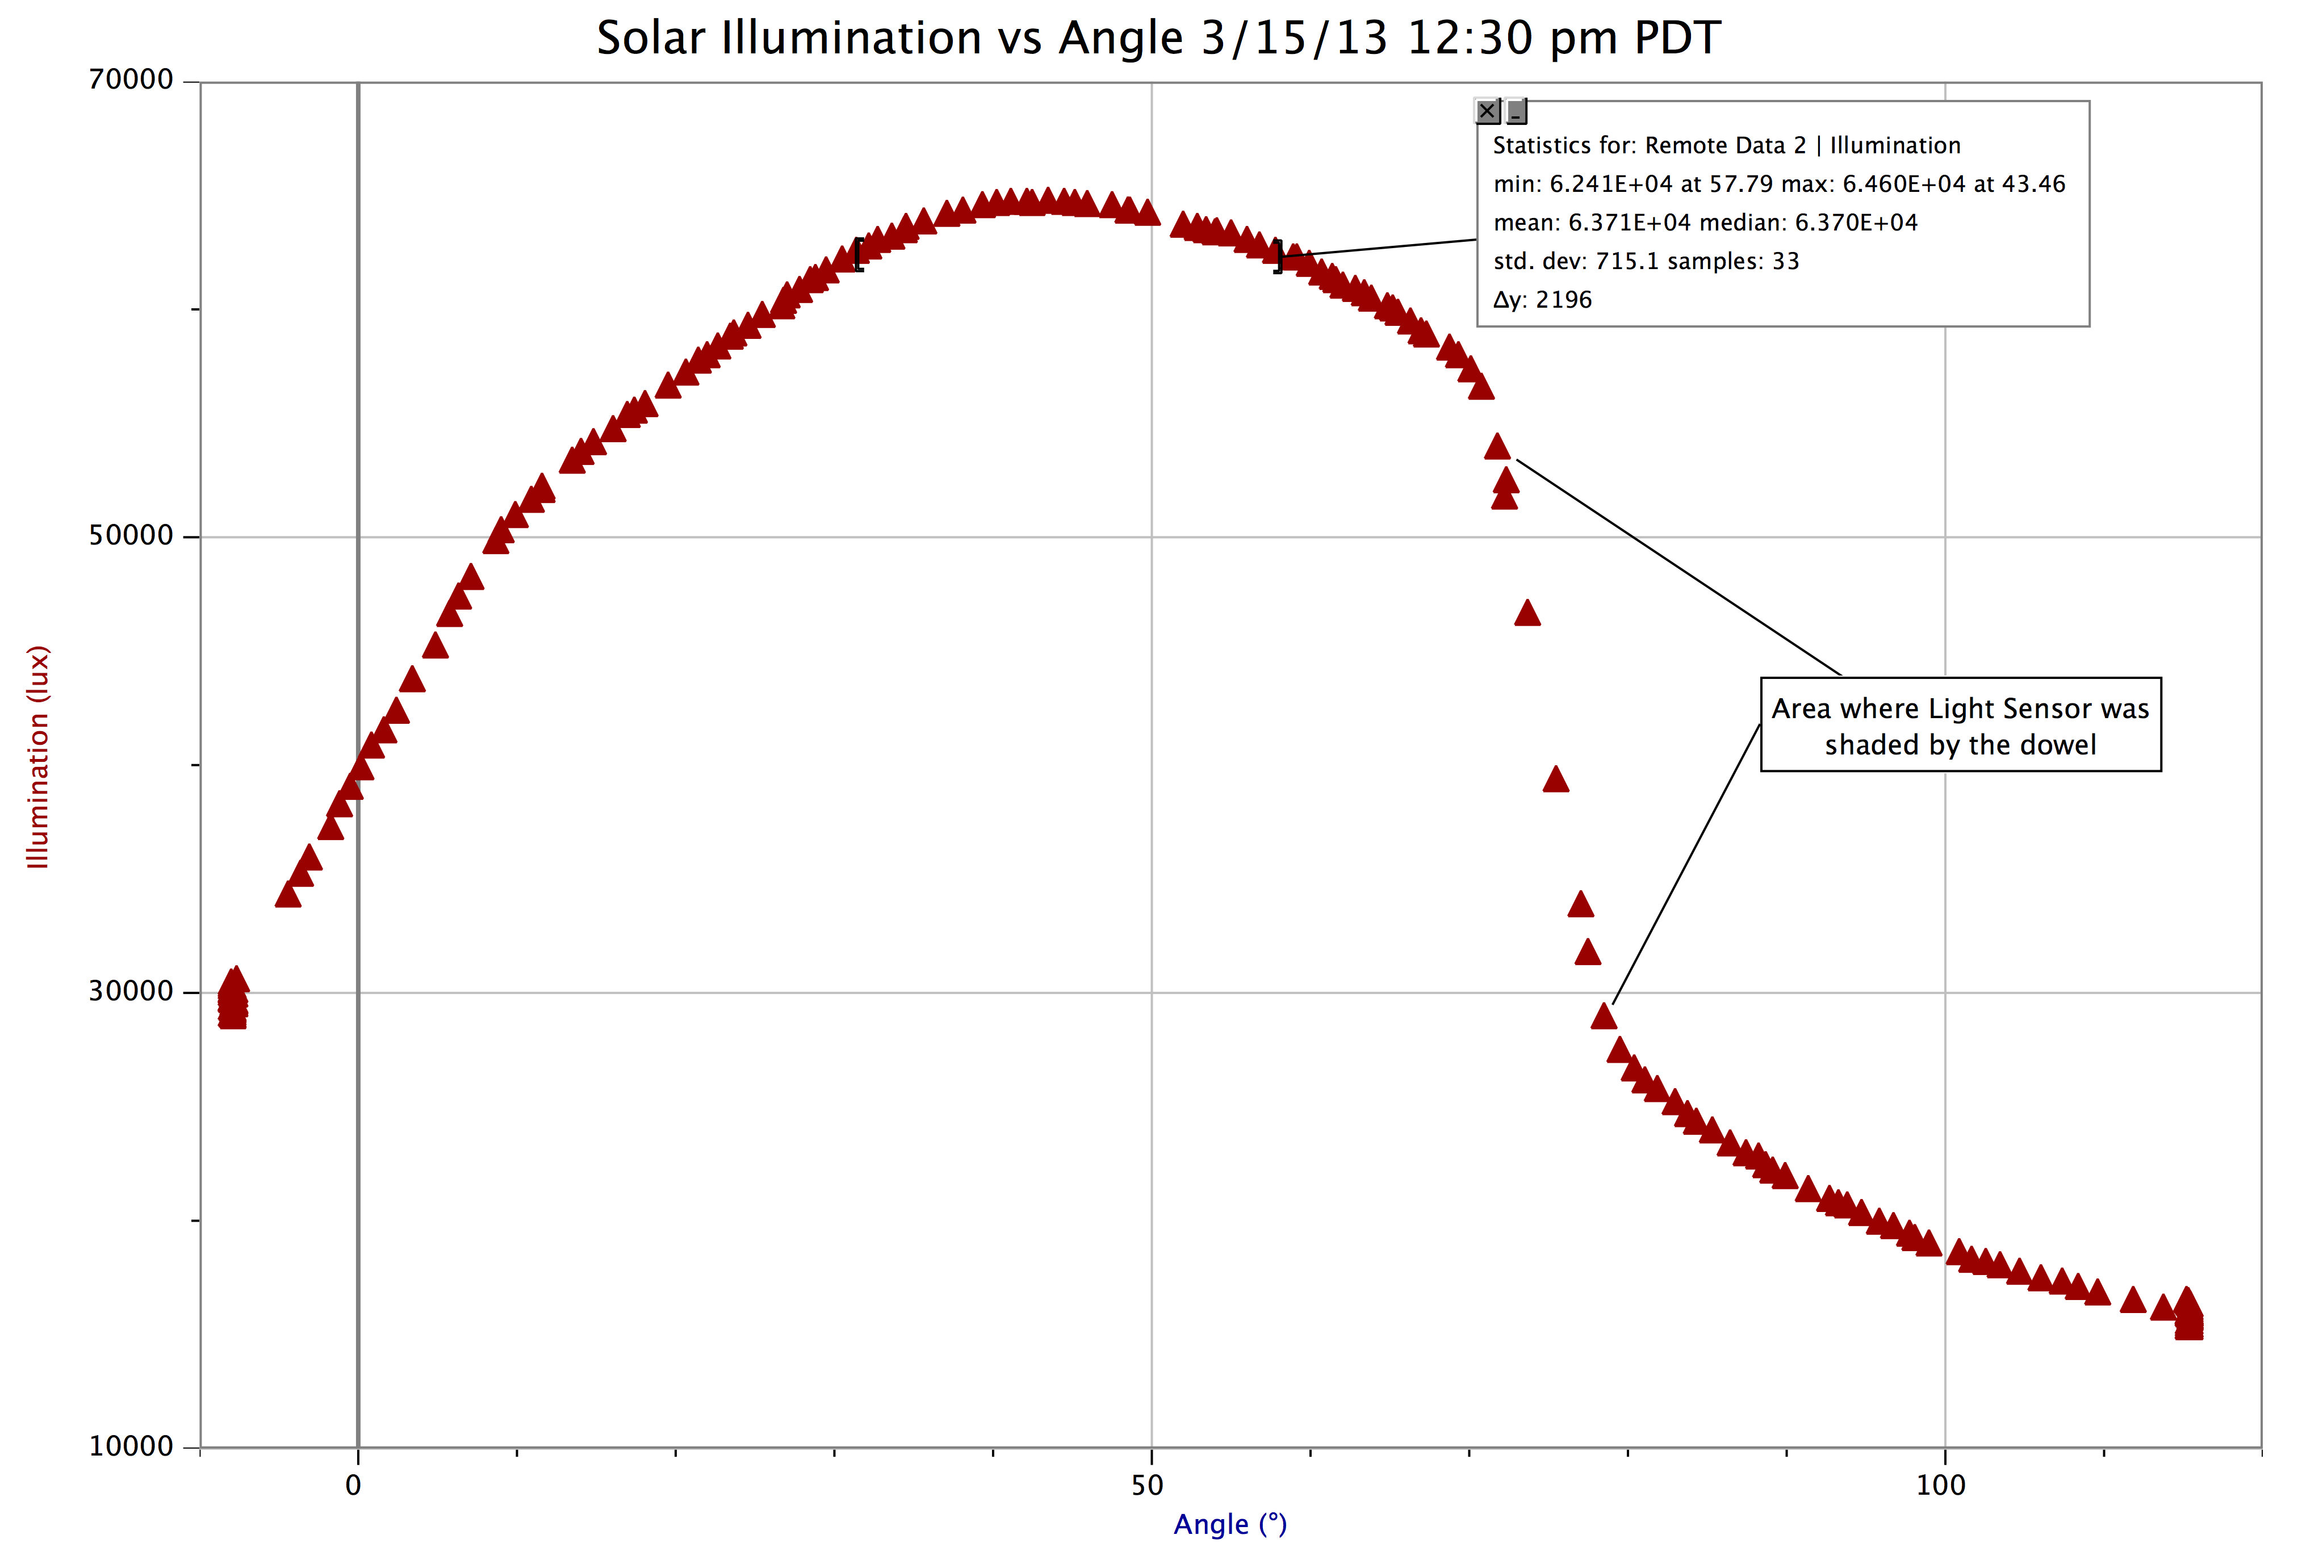
Sample data taken to prove concept.

LOGBOOK SAMPLE

Date | Time | θ_{max} | I_{max} | Compass Angle

ADDITIONAL QUESTIONS

- If you set the apparatus to a fixed vertical angle, say 45°, how does the intensity of sunlight change over the course of a day?
- Coordinate your data collection with students at another school at approximately the same longitude but different latitudes. How do the results compare? How are they the same and how are they different?
- Coordinate your data collection with students at another school at approximately the same latitude but different longitudes. How do the results compare? How are they the same and how are they different? How are you going to handle collecting data at the same time?

GONIOMETER APPARATUS PREPARATION

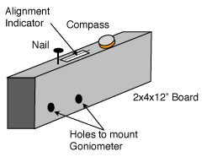

- Materials: 2x4x12” board, 3/8” wood dowel 10” long, carriage bolts (2), wing nuts (2),
6-32 x ¾” bolt, nail, paper with line, glue or transparent tape, magnetic compass. Tools: drill, drill bits
- Drill two holes to accommodate the carriage bolts to hold the Goniometer. The use of wing nuts makes it easy to install or remove the Goniometer. Wood screws can also be used in place of the carriage bolts.
- Drill a hole in the top so a nail sticks out approximately 1.5”. The shadow of this nail is used to align the apparatus with the sun. A second hole that allows most of the nail to be encased in the board can be used to hold it between uses.
- A piece of paper with a line down the center can be taped or glued to the top of the board. When the shadow of the nail hits the center line the apparatus is aligned with the sun.
- A magnetic compass can be mounted using double-stick tape if you are studying the sun’s compass angle during the day and/or year.
- Mount the Goniometer on the piece of 2x4 as shown, making sure the moving arm can swing vertically upward. Using two carriage bolts with wing nuts will make it easy to set up the unit, although a c-clamp could also be used or wood screws.
- Drill a 3/32” hole near the end of the wood dowel. Make sure the 6-32 bolt will pass easily through it.
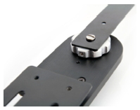
- Unscrew the flexible arm from the Goniometer and replace it with the dowel. Orient the setscrew for the dial so it’s next to the silver dot as shown on the right.
- Attach the Light Sensor to the dowel with rubber bands.

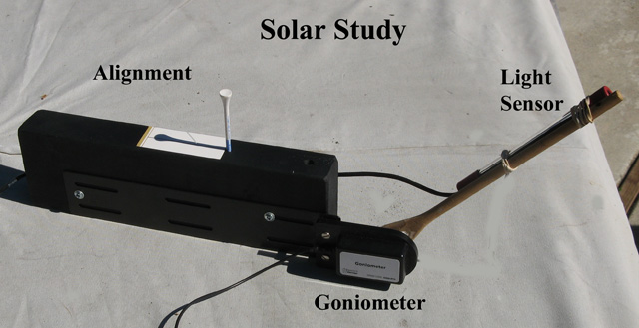

OTHER ALTERNATIVES

- One alternative would be to replace the Goniometer with a Rotary Motion Sensor (RMV-BTD). The arm used to hold the light sensor would still be a dowel, but the bolt used to hold it to the sensor is smaller – 4-40. Or if you have the Rotational Motion Accessory Kit, the hollow aluminum rod from the kit could be used. The Rotary Motion Sensor is a digital device, so the use of two Go! Links is not possible. Any of the other options in terms of interface could be used, however.

- A second alternative would be to use a Low-g Accelerometer (LGA-BTA) to measure angle. Mount the accelerometer on a short board (perhaps 1”x4”x18”) with the axis aligned to the length of the board. Mount the light sensor on the board, also. As you raise the board, the accelerometer units can be converted into angle by taking
sin⁻¹ (Reading/9.8). While this setup is the simplest in terms of equipment, the software has more work to do.
1x4 Board
Accelerometer
Light Sensor
Nail

OTHER EXTENSIONS

- How much light comes from the moon? Over the course of a night, how does the illumination from the moon change? How does it change as the phases change?
- We could make a small, light platform and mount it where the moveable arm is located. Then set up a fairly narrow slit in front of a light sensor at a fixed point beyond the edge of the goniometer. On the platform, put a laser pointer and perhaps a single or double slit at the center of rotation. Then as you rotate the platform, the angle will be known and the amount of light getting into the sensor will be measured, giving you the diffraction or interference pattern.
Goniometer
Laser Pointer
Platform
Grating
Slit
Light Sensor
- Another possible use might be putting a microphone at the center of rotation and not rotating it, but taking a small sound source on an angular trip, measuring the amount of sound versus the angle. Should show the spacial response of the microphone.

From Roger Larson, retired physics teacher in Boulder, CO:

- Use a similar setup to track the angle of a launched rocket.

- Set up the Goniometer so a horizontal angle is measure. From two baseline points, a measured distance d apart, use the apparatus to measure the angles to a third, distant point. Determine the distance using triangulation.

- Use the apparatus to measure the angle of a tall building when standing a known distance away, applying the tangent function to calculate the building's height.

CBakken
Updated 6/2016

