Video Analysis of Basketball Shot
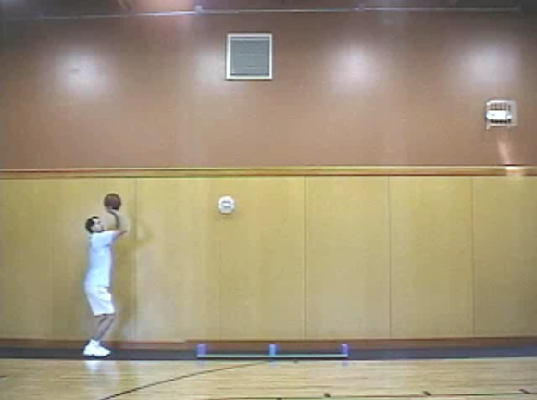
The following steps will allow you to obtain a file to study the flight of a basketball. Vernier Software created a video file that can be used. Using it for this activity will teach you to use video analysis for other activities.

- Launch Logger Pro 3.x (Current version, 3.6.0 recommended). No interface or sensors are needed.

- To use the prepared file:
File > Open > Sample Movies > Basketball Shot > Basketball Shot.cmbl

- To set up a new file from a piece of video:
- Start with a fresh Logger Pro file - go to File > New. Go to Insert > Movie, then navigate to the video file you wish to use.
- Once the video has been loaded into Logger Pro, press the button to activate video analysis. At this point we recommend that you go to Page > Auto Arrange to adjust the sizes of the various windows on your screen.

- When the file is loaded, click on the Play button under the video

- While viewing, these buttons will control things:
Stop | Go back a frame: :Go ahead a frame

- Now use the scrub bar (the moveable video cursor) and/or the frame-by-frame buttons to move the ball until it has been launched and is free of the shooter’s hands.

- Click on the second button down on the right side of the video, the "Add Point" button.

- Move the cursor to the ball and click a spot on the ball. (Hint: Use the bottom of the ball for best results. Note that a dot is left on the screen to mark this point and the video moves ahead one frame.

- Continue marking the ball's position on a frame-by-frame basis until just before it hits the floor.

- Click on the 4th button on the right to "Set Scale". Drag the cursor from one end of the 2-meter stick that’s on the floor to the other and then type "2" into the dialog box that pops up to indicate that the scale length is 2 meters. For your own video analysis, you’ll need to have an object in your screen for which you know the length.

- Click the 3rd button on the right to "Set Origin". Move the cursor to the first ball position then click the mouse. Move the origin by holding down the left mouse button when the cursor is over the origin then dragging. You may wish to position the x-axis along the floor directly under the ball, establishing the floor as the zero height.

- Set up the graph so the vertical axis is "Y", the vertical position. [Click on the vertical axis label. A menu will appear from which you can choose the quantity you wish to graph.] Examine the graph that has been drawn. What does it represent? Besides a basketball that has been shot, what else could have made such a graph? Describe the graph as completely as possible. Complete additional analyses that make sense.

- Set up the graph so the vertical axis is "X", the horizontal position. Examine the graph that has been drawn. What does it represent? Besides a basketball, what else could have made such a graph? Describe the graph as completely as possible. Complete additional analyses that make sense.

- Set up the graph so the vertical axis is "Y Velocity", the vertical velocity. Examine the graph that has been drawn. What does it represent? Besides a basketball, what else could have made such a graph? Describe the graph as completely as possible. Complete additional analyses that make sense.

- Based on the analyses that you completed in steps 12-14, describe the motion of the basketball as completely as possible, citing numbers that were calculated. Also state as succinctly as possible the major overriding behavior of a basketball while it is moving through the air under the influence of gravity and inertia.

The motion of the basketball is typical of any number of objects that are launched near the earth’s surface. Their motion is due to two factors: Inertia and Gravity. Such objects are collectively called Projectiles, although they may be as different as baseballs and shot putts, golf balls and water balloons.

You can learn more about Video Analysis by studying the tutorial. Inside Logger Pro,
Open > Tutorials > 12 Video Analysis

C. Bakken
June 2008

